**Cnidaria:**

_______________________________________________________________________

Background information

The cnidarian body consists of a central blind sac, the coelenteron (= gastrovascular cavity), enclosed by a body wall comprising two epithelia, the outer epidermis and the inner gastrodermis. In some classes the term coelenteron is typically used and in others researchers use the term gastrovascular cavity. A gelatinous connective tissue layer, the mesoglea, lies between the two epithelia. The mouth opens at one end of the coelenteron and marks the oral end.  The mouth is at the tip of a process, the manubrium that elevates it above the oral surface. The opposite pole is the aboral end.  The imaginary line connecting the oral and aboral poles is the axis of symmetry around which the radial symmetry of the body is organized.  The mouth is usually surrounded by one or more circles of tentacles.

**The defining cnidarian feature is, of course, their possession of stinging cells, or cnidocytes**. Characteristic of the epidermis, they are also sometimes found in the gastrodermis.  Cnidocytes contain an explosive organelle, the cnida, which, upon proper stimulation, inverts and ejects a slender, often barbed and toxic thread in the direction of prey or predator Three overall types of cnidae are found in cnidarians.  Nematocysts (in nematocytes), spirocysts (in spirocytes), and ptychocysts (in ptychocytes).  All toxic cnidae are nematocysts whereas spirocysts are sticky, and the everted tubules of ptychocysts are used for constructing feltlike tubes**.  Most cnidae are nematocysts and these are present in all three higher cnidarian taxa.** Spirocysts and ptychocysts are found only in Anthozoa.

**The basic body plan described above can be manifest as a swimming medusa or attached polyp. In some taxa only one generation is present whereas in others both are found.  A life cycle featuring alternation of sexual, swimming medusae with benthic asexual polyps is typical of many cnidarians.**

All cnidarians are carnivores feeding on live prey, which they usually capture using tentacles armed with cnidocytes. Digestion occurs in the coelenteron, which is typically equipped with ciliated canals for distribution of partly digested food.  Diffusion across the body and tentacle surface eliminates the ammonia from the body.  Gas exchange is across the general body surface. The nervous system is a plexus of basiepithelial neurons serving sensory and motor systems. Most cnidarians are gonochoric (sexes are separate).  The life cycle typically includes a planula larva.  Cnidarians are chiefly marine but the well-known *Hydra* is an exception.

**Classification of Cnidaria:** 3 or 4 clades, Life cycle differences define the various clades.

**Hydrozoa:** Hydroids. Usually both polyp and medusa. Polyp stage if present is dominant stage.

**Scyphozoa:** Jellyfish. Medusa dominant, polyp reduced

**Cubozoa:** Some authors consider the Cubozoa ( "sea  wasps" and "box jellies" ) to be a clade, the Cubomedusae, of the Scyphozoa. Medusa dominants. Box like construction to medusa.

**Anthozoa:** Anemones and corals. Polyp only

Most of the specimens you will be examining will belong to the class Hydrozoa.

**1.** **Obtain a hermit crab or at least a shell containing a colony of *Hydractinia echinata.*  Identify if you can at least four types of individuals**. **Draw the different individuals you see. Graph the colony indicating the position of the various individuals to each other**. Do not attempt in this drawing to show each individual but do indicate relative numbers and overall pattern. Watch carefully for epifauna. Various tubed annelids often live among the hydroids. Although considered a plus for the annelids that are protected, this relationship may be a minus for the hydroid colony as I have seen the worms steal food from the hydroids. Also look for other hydroids that may be competing with *Hydractinia echina* for space. Colonies that have to share their shell with these competitors may have different numbers of different individual or place their individuals in different positions relative to the intruding species. If you had to design a colony where would you place reproductives relative to defense individuals? Would the placements vary dependent on whether competitors were present or absent?

Colonies are often male or female (or more strictly speaking have only male or female gonozoids). Can you tell whether the colony on your shell is a male or female colony? Construct hypotheses regarding different conditions and then see if the distribution supports your hypotheses. Each pair should collect data on one shell.

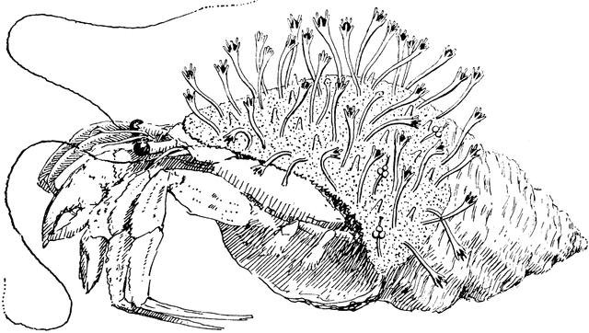 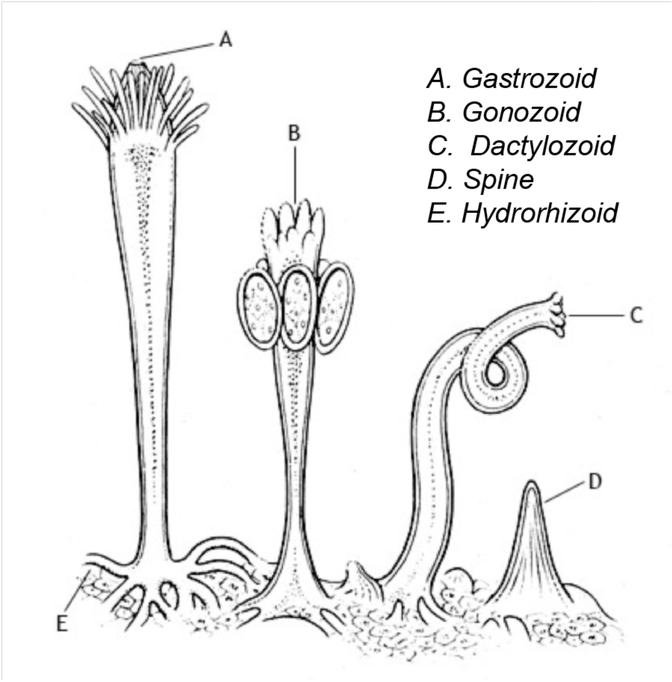

Another diagram that divides the colony into non reproductive zooids and female and male reproductive zooids.

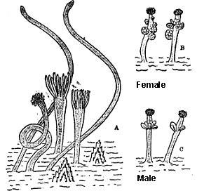**\\**

**Shells for your to use to plot distribution of different zooids. Choose the shell shapes that best fit the shell of your crab.**

**Shape one: Most common shape**

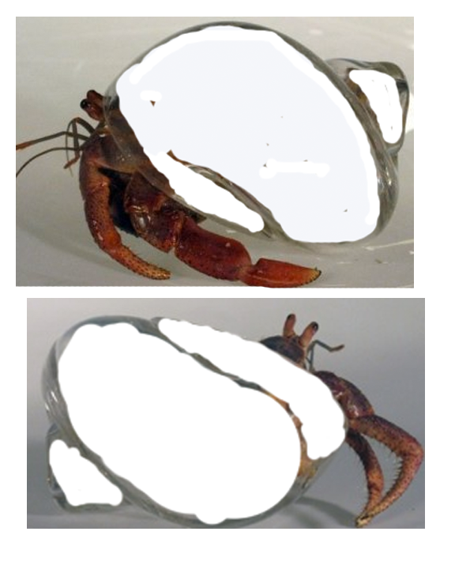

Are there any polyps on the underside of the shell? Use the diagram below.

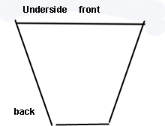

Shape two, front, side views and ventral (bottom) of shell

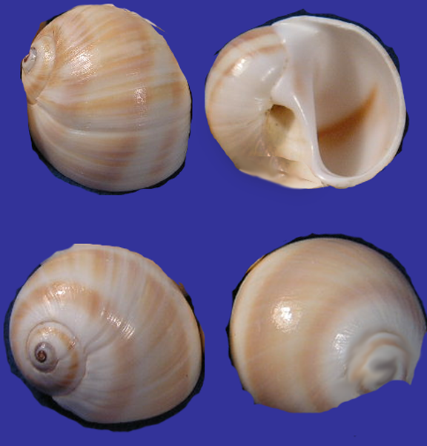

Shape three:

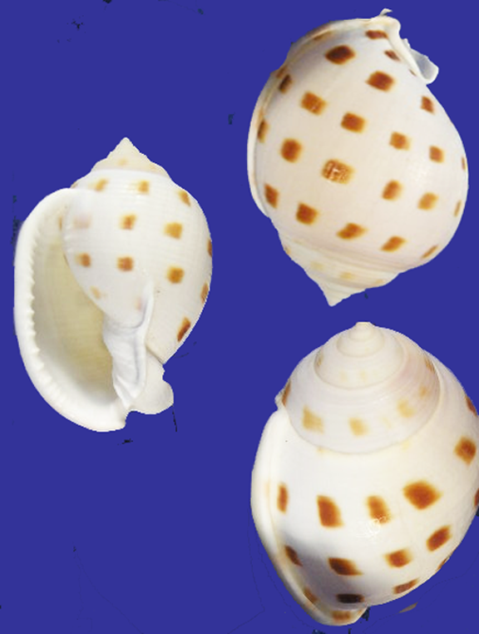

***_________________________________________________________________________***

**2 . Survey of colonies of various hydrozoans.**

**You will continue to look at variation among the class Hydrozoa. *In all specimens examined, you should determine (if only from the web) what life stages to expect and whether the colonies exhibit polymorphisms.***

***Each pair should compare 2 hydroids***

*.*

a.  **Take photographs of the different types of polyps present.** In your journal compare and contrast the different types of polyps found.

For example, make observations as the following. “It looks like in Tubularia, feeding polyps prevail and in Pennaria, reproductive individuals prevail. It looks like some of the reproductive polyps are developing medusa, although medusa are far from being released.” Use gloves, as all cnidarians sting, although most of the available species, produce medusa and polyps so small, you probably will not be able to feel their sting.

**b. Describe feeding in your specimens**

**c . Characterize the shape of the colony and spacing of feeding versus other types of zooids.** Are all the gonozoids at the colony edges or in the middle of the colony? Are zooids only found at the terminal tips of hydroids or are they spaced regularly on the branching stolons.

**Specimens that may be available**

**Pennaria spp May be here next lab.**

In Pennaria tiarella, medusa buds develop and are retained along sides of hydranths.. Generally colonies are male or female, although the medusae of both sexes look alike and are difficult to distinguish. In other species, medusa may be released and develop from gonophores produced at the edges of branches.

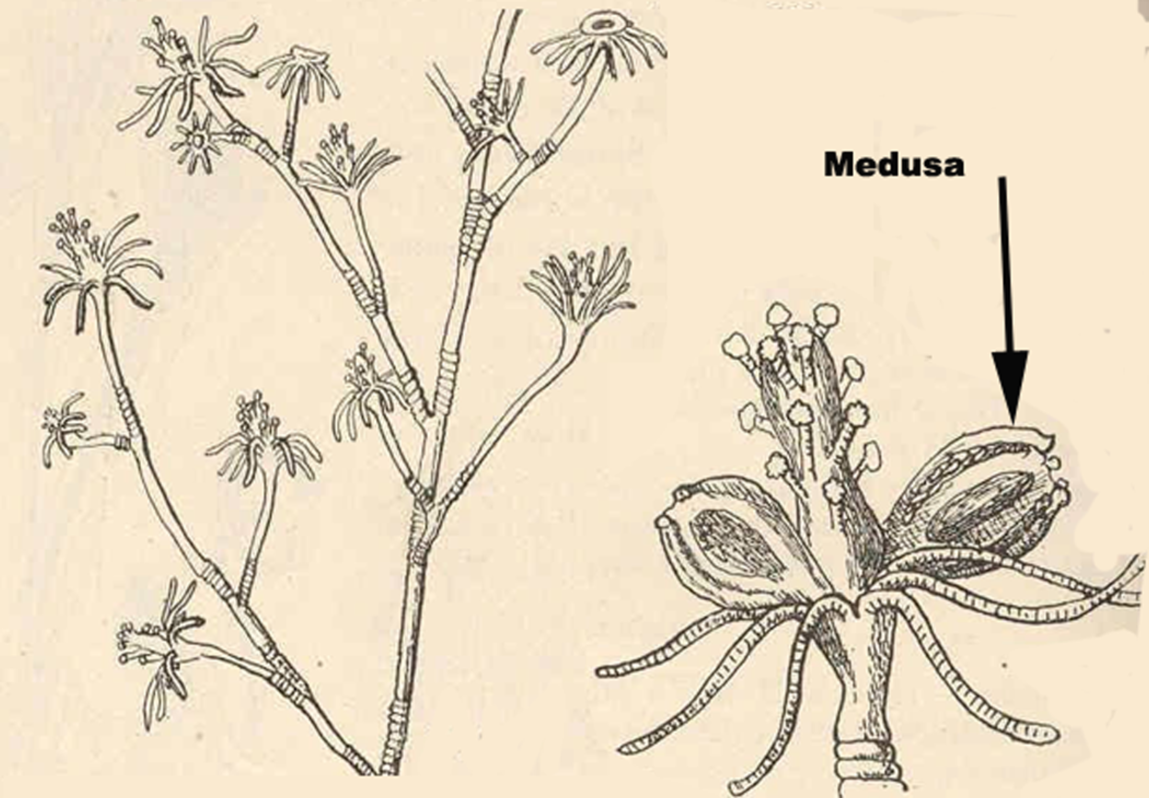

**__________________________________________________________________**

**Sertularia sent**

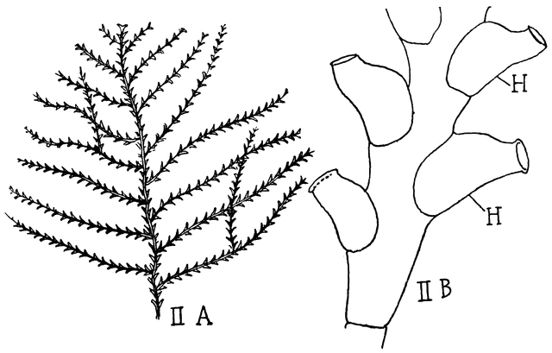

This species is often limited in nature to area of strong flow. he main stem gives rise to side branches of determinate length which branch dichotomously. They bear hydrothecae which are arranged subalternately along opposite sides of the branches, turned slightly towards the distal end of the colony. The outer part of each hydrotheca is turned slightly away from the branch. Gonothecae are borne abundantly on these side branches

***--------------------------------------------------------------------------------------------------***

***Obelia or Campanullaria.*** *Obelia* forms a long white branching colony more than ten centimeters long. The polyps of *Obelia* are housed in transparent cups for protection. When touched or exposed to the microscope's light the tentacles will withdraw into the cups. This species is the only one in the laboratory that will produce obvious medusae, which are released from the gonozooids, producing free-swimming male and female medusae velum with gonads, a mouth, and tentacles. The physical appearance of the male and female medusae velum, including their gonads, are indistinguishable, and the sex can only be determined by observing the inside of the gonads, which will either contain sperm or eggs. The medusae reproduce sexually, releasing sperm and eggs that fertilize to form a zygote, which later morphs into a blastula, then a ciliated swimming larva called a planula.

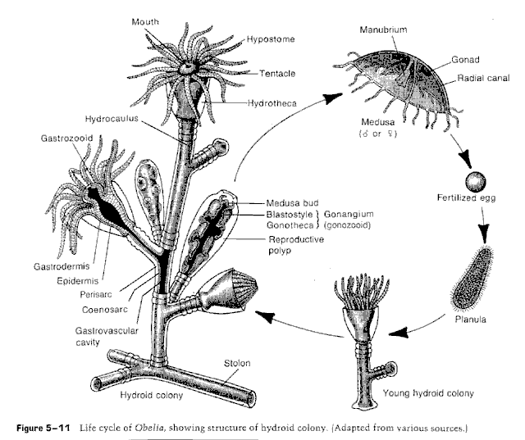

Campanularia sent.

*Campanularia sp.* May be substituted for Obelia. Polys look that same. They are in the same family, but medusa are different, Campanularia being more boxlike.

*--------------------------------------------------------------------------------------------------------------------------*

*Clava?* No species is specified. Some form sport some very spectacular colonies with gonozoids attached rather than next to gastrozoids, but it’s a guessing game until we actually receive the specimens. Suspect if sent, colony will be Obelia in polyp morphology. View Clytia instead on COVID films.

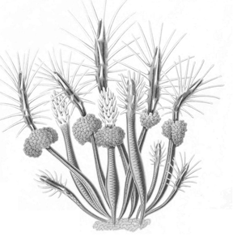

*Tubularia* ***Requested not sent. ON COVID FILMS Prettiest of them all.***

A spectacular polyp with bright pink or orange gonophores, which develop into attached medusae. Sperm are released by male medusae and attracted to female medusae. Fertilization is internal. So, medusa are produced but not released. They stay attached to the polyp. **This is the genus, you photographed last week.**

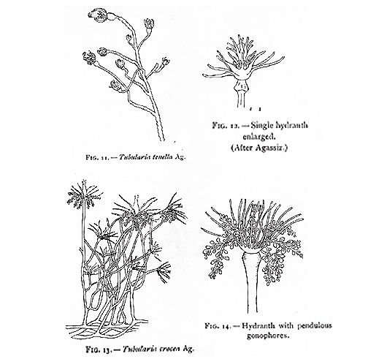

**If time permits.**

**Scyphozoans**

**3. Your last activity will be an examination of a Scyphozoan**.

You will examine the medusa, or prominent stage in the life cycle of a Scyphozoan. Polyps may also be available.

The upside down jelly is an Scyphozoan. We have several adult specimens. The lab that furnishes them does not identify the species sent..

They have a symbiotic relationship with a dinoflagellate (zooxanthellae) that lives within their tissue, very similar to corals but also filter feed through secondary mouths on phytoplankton By lying upside-down, the mangrove upside down jellyfish exposes its algae to the sun, allowing it to photosynthesize. They release globes connected sometimes by mucous strings that contain algae cells, nematocysts and other ciliated cells that may aid in dispersing the globes. There is some disagreement about the function of these “cassiosomes”, with most scientists feeling that the jellies are building a protective wall around themselves. However since these are produced frequently while the jellies are feeding, some feel they may play a role in supplemental feeding and specimens may take in mucous strings some time after pulse feeding. Please use caution when handling these animals. Animals should be returned to holding dishes with as little water as possible. Discard water and inform TA if the holding dish is becoming cloudy or contains mucous, so water can be changed.

Note the complexity of structure of its medusa. You can compare this to the simplicity of the hydrozoan medusa in the lecture guide. Note the region devoted to feeding, he edges of its eight oral arms are fused and folded into elaborate frills containing hundreds of tiny mouth openings. The mouth openings are connected by channels to its stomach. By pulsing its bell, it forces zooplankton into the nematocysts on its mouth openings.

Try feeling your specimen, some Daphnia, coral food or phytoplankton.

Jellyfish gonads develop in the lining of the gut; thus, the sperm is released from the mouth. The “magic” happens when the female swims through the cloudy waters. Depending on the species, the females carry their eggs in a brood pouch or in their stomach, so fertilization occurs in one of these locations.

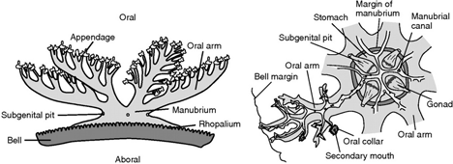

Please examine the specimens we have and see if you can distinguish the secondary mouths on the medusa. Take a photograph and label the Oral cavity and secondary moths**.**

Typical life cycle of a scyphozoan. This is a general diagram and not that of the upside down jellyfish. It is important to note that this life cycle includes a polyp stage.

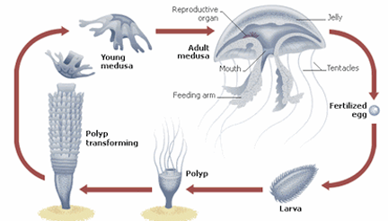

**.**

We are fortunate to have the polyp stage of our upside down jellies in the laboratory right now. **Obtain a polyp and compare its structure to that of a hydrozoan polyp.** You can use the pictures obtained last week. We also have specimens of *Pennaria* *tiarella* and another hydrozoan *Eudendrium carneum.* The picture that would be worth a thousand words in your journal would be one with polyp of one of the hydroids next to that of the underwater jelly fish. **Discard polyps used. We do not want to mix cultures.**

At the end of this laboratory, you should be able to compare the stages found in life cycles of Anthozoans, Scyphozoans, and Hydrozoans. You should also have become familiar with the structure of nematocysts and built an appreciation for the types of symbiotic relationships cnidarian have with various algae.

Only if time. Please spend as much time as you need with the first two exercises. We culture Aiptasia. So you will be able to do these exercises after break week.

4. Aiptasia the model sea anemone: The external morphology of anemones is limited to a column; an oral disk, in the center of which the mouth is located, and on which the tentacles are located; and either a pedal disk, that affixes the anemone to the substrate, or a bulb-like physa, used by burrowing anemones to anchor in soft substrate.

.

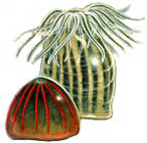

*Aiptasia pallida*, or related species, has long tentacles and demonstrates partial retraction. Because they reproduce by budding, a few well-fed individuals will soon multiply to hundreds and cover the rocks like soft brown fuzz.

Obtain and examine a specimen of *Aiptasia pallida*. This anemone, contains symbiotic dinoflagellates or unicellular algae.

*Apitasia* is fairly transparent and so you should be able to see the food moving down into the gut. It feeds on most motile organisms. It will often take animals twice or three times its size.

Feed your specimen a small piece of fish food.

**For the next lab. ?**

How close is the prey before the anemone response to it. Do the tentacles move toward the prey or does the prey have to contact the tentacles before the anemone responds. How does the sea anemone move the prey animal into the digestive cavity? Can you see any other details of internal anatomy in your specimen? **Record your observations in your journal.**

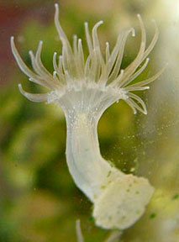

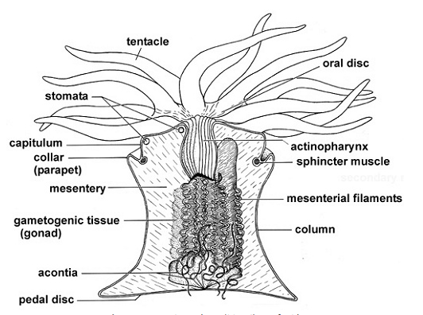

**Pairs should exchange information and then all should be able to look at cnidoblast cells at the same time.**

Your teaching assistant will choose a specimen to use to examine the stinging cells or cnidoblasts. Obtain a tentacle or two and place under 100 or 200 x. Look closely at the surface to see the conspicuous spherical **nematocysts**.  These are the explosive capsules of cnidocytes.  The cnidocytes themselves will probably not be discernable but their capsules are abundant and conspicuous. You may also see some yellow to yellow orange circular cells that are spilling out of the tentacles. These are symbionts, or dinoflagellates found in this species.

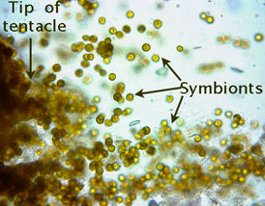

Some pairs may want to place the acontia or white protective threads that appear when the anemone feels threatened, (as when its tentacles are cut off). Anemones can have cnidocytes lining the inside of the gastrovascular cavity and their acontia.

Look at one of the tentacles with 400X.  Note the different sizes of **nematocysts**.  Most of the nematocysts will be intact and unexploded but some will have discharged.  Find some of the large ones, focus carefully, and look for a coiled **thread** inside the capsule.  If the thread is present, the nematocyst is undischarged.  Look around for some **discharged nematocysts**.  These will look quite different.  They are obviously empty, having everted their **thread**, which can be clearly seen extending away from one end of the empty capsule. With careful focusing and light adjustment you can also see the formidable **barbs** at the base of the thread adjacent to the empty capsule.

Place a drop of 1% acetic acid beside the coverslip and draw it under *while watching* through the microscope.  The acid may stimulate the discharge of many of the nematocysts and, if you are fortunate, you may actually see one of them discharge as you watch.  A drop of toluene blue applied the same way will stain the nematocysts, making them easier to see.

**Obtain (a.) a photograph of a tentacle, discharged nematocysts and symbionts. Identify symbiotic algae and nematocysts on the photograph**.

.